Name :: Muhammad usama :

Rool no:: 17f_8195:

Section ::B

Lab ::2

Task 1:

#include<iostream>

using namespace std;

int main()

{

bool flage=true;

int arry[1000]={0};

int size=0,temp=0;

cout<<"enter the size of arry : ";

cin>>size;

for(int i=0; i<size; i++)

{

cout<<"enter "<<i+1<<" element of an arry : ";

cin>>arry[i];

}

for(int iter=1; iter<size && flage==true; iter++)

{

flage=false;

for(int i=0; i<size-iter; i++)

{

if(arry[i]>arry[i+1])

{

flage=true;

temp=arry[i];

arry[i]=arry[i+1];

arry[i+1]=temp;

}

}

}

for(int i=0; i<size; i++)

{

cout<<arry[i]<<" ";

}

system("pause");

return 0;

}

Result::random:

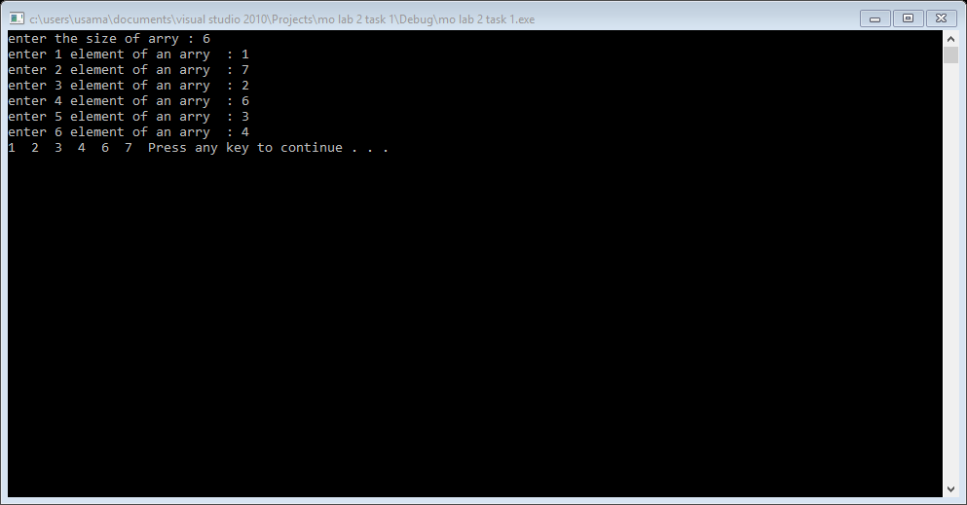

Result::nearly sorted::

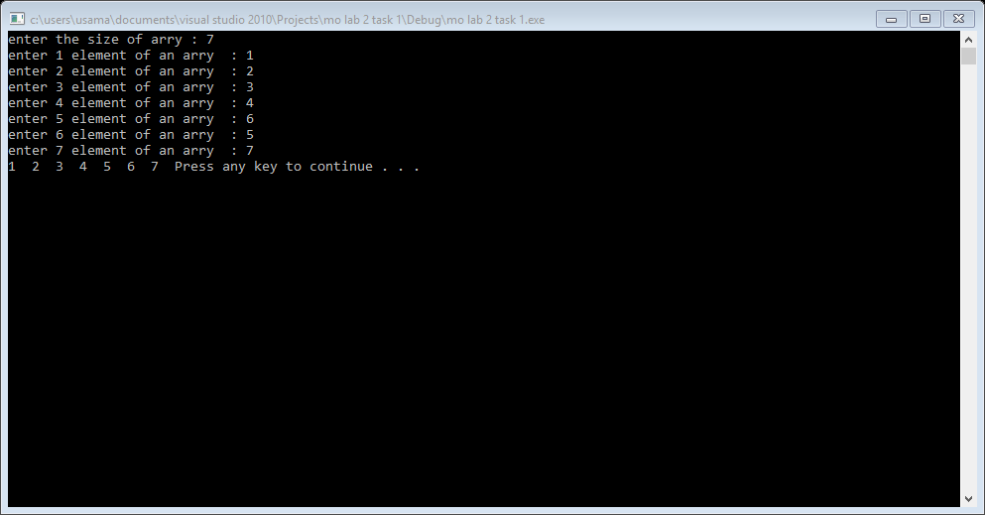

Result::redundant::

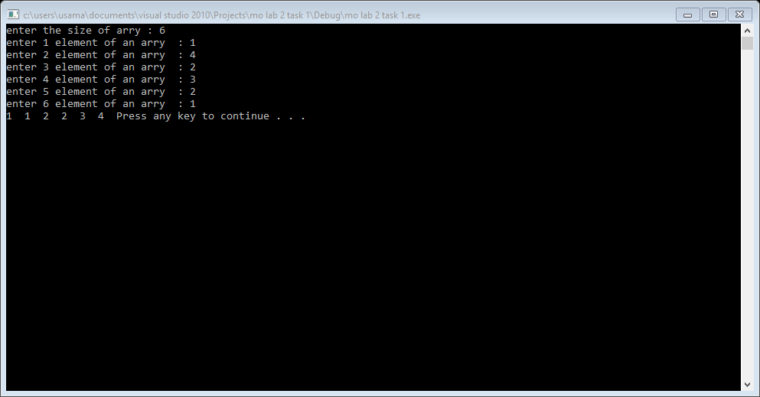

Result::reversed::

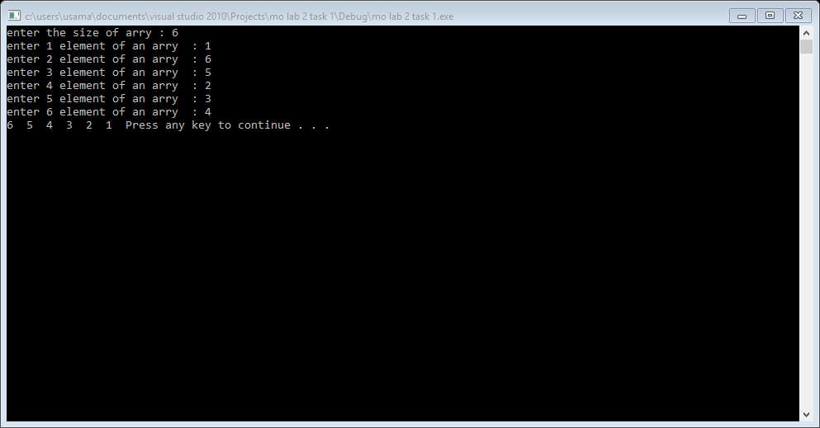

Task 2:

#include<iostream>

using namespace std;

int main()

{

bool flage=true;

int arry[1000]={0};

int size=0,temp=0,i=0,smalli=0;

cout<<"enter the size of arry : ";

cin>>size;

for(int i=0; i<size; i++)

{

cout<<"enter "<<i+1<<" element of an arry : ";

cin>>arry[i];

}

for(i=0; i<size; i++)

{

smalli=i;

for(int j=i; j<size; j++)

{

if(arry[j]<arry[smalli])

{

smalli=j;

}

}

temp=arry[smalli];

arry[smalli]=arry[i];

arry[i]=temp;

}

for(int i=0; i<size; i++)

{

cout<<arry[i]<<" ";

}

cout<<endl;

system("pause");

return 0;

}

Result::random::

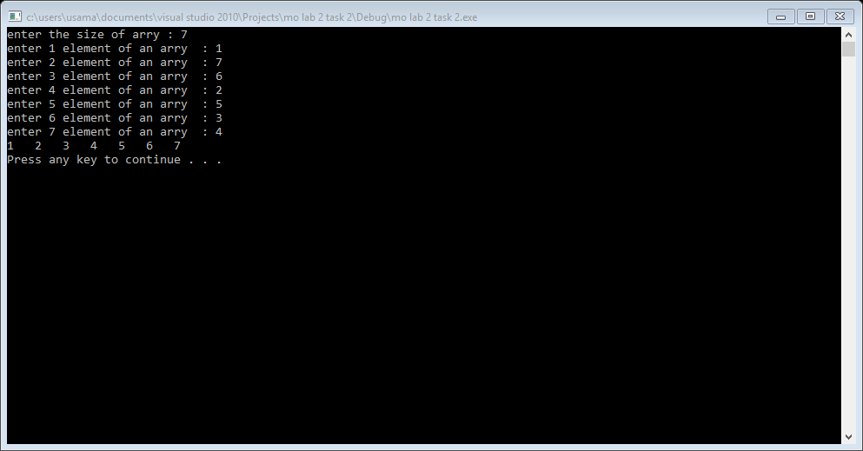

Result::nearly sorted::

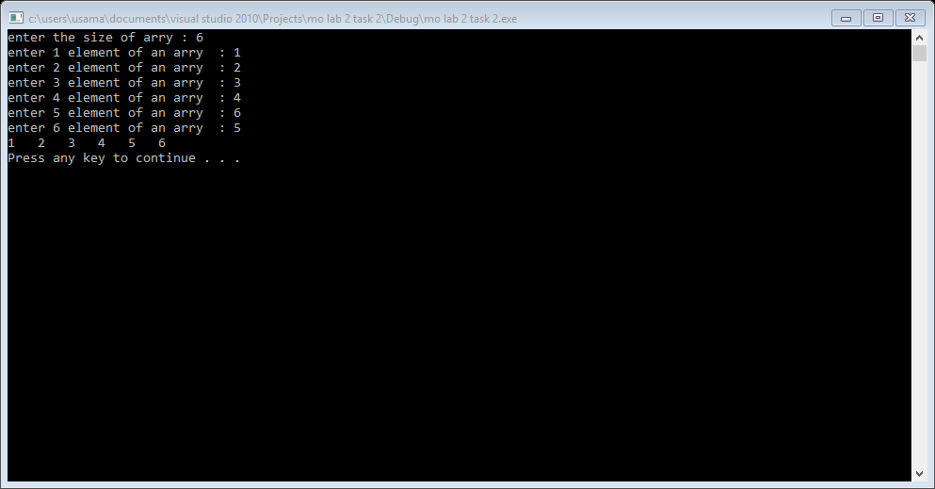

Result::redundant::

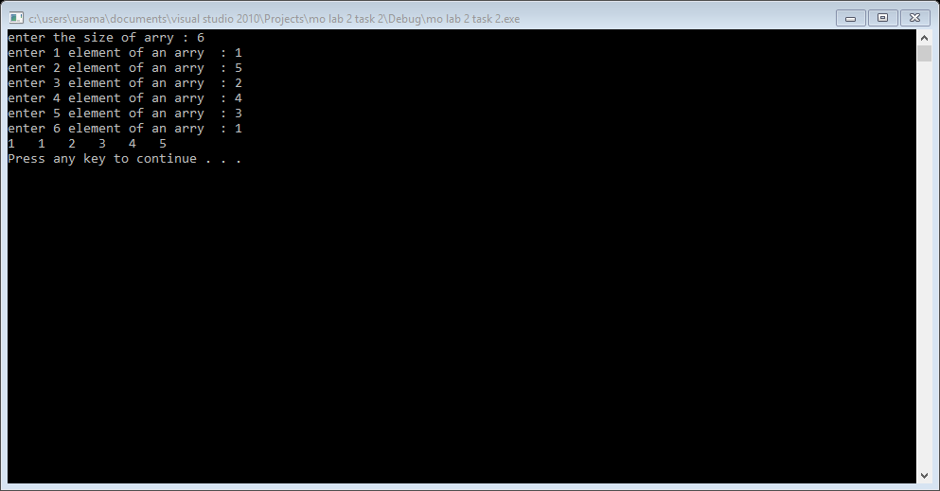

Result::reversed::

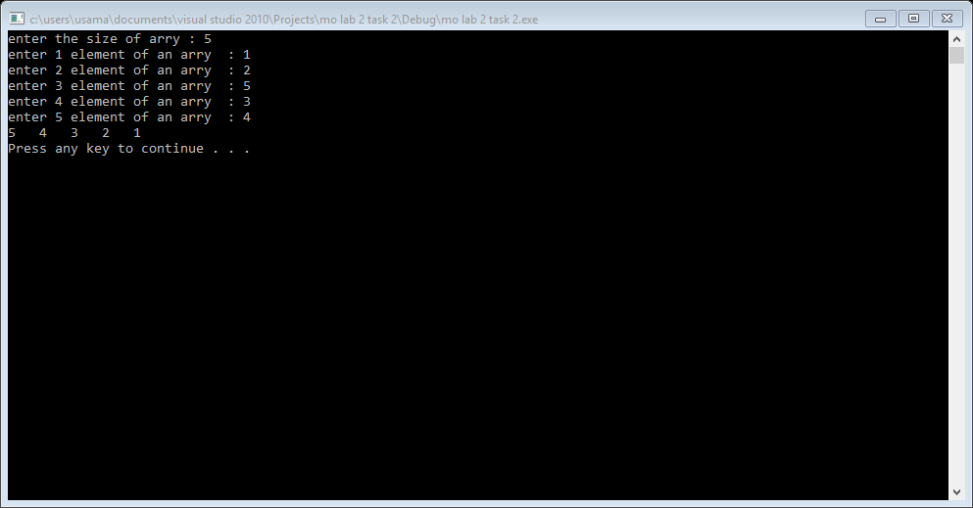

Task 3::insertion sort::

#include<iostream>

using namespace std;

int main()

{

int arry[1000]={0};

int size=0,temp=0,location=0;

cout<<"enter the size of arry : ";

cin>>size;

for(int i=0; i<size; i++)

{

cout<<"enter "<<i+1<<" element of an arry : ";

cin>>arry[i];

}

for(int second=1; second<size; second++)

{

if(arry[second]<arry[second-1])

{

temp=arry[second];

location=second;

do

{

arry[location]=arry[location-1];

location--;

}

while(location>0 && arry[location-1]>temp);

arry[location]=temp;

}

}

cout<<"sorted arry : ";

for(int i=0; i<size; i++)

{

cout<<arry[i]<<" ";

}

cout<<endl;

system("pause");

return 0;

}

Result::random input::

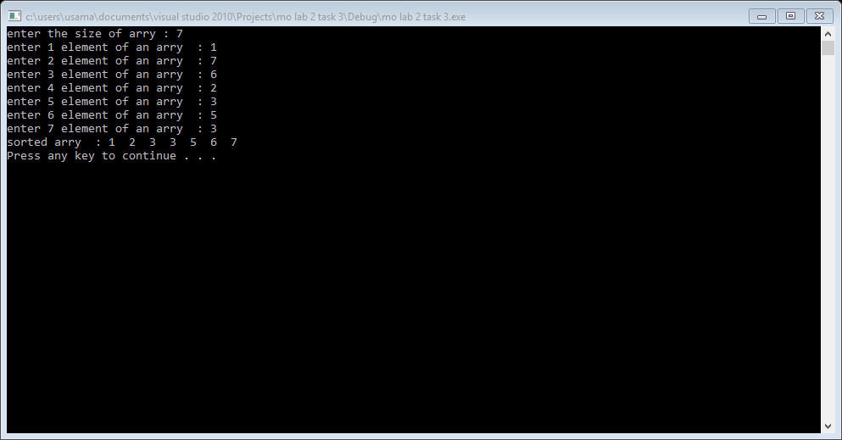

Result::nearly sorted::

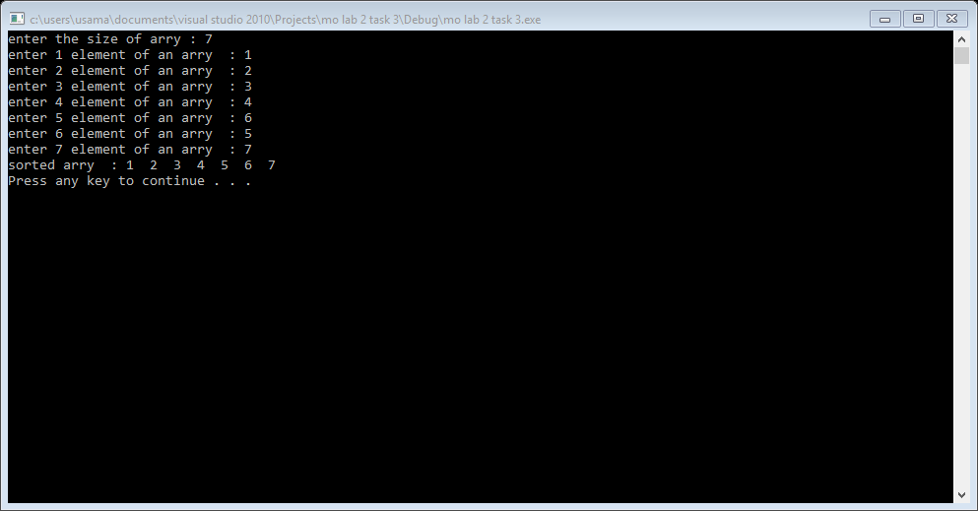

Result::redundant input::

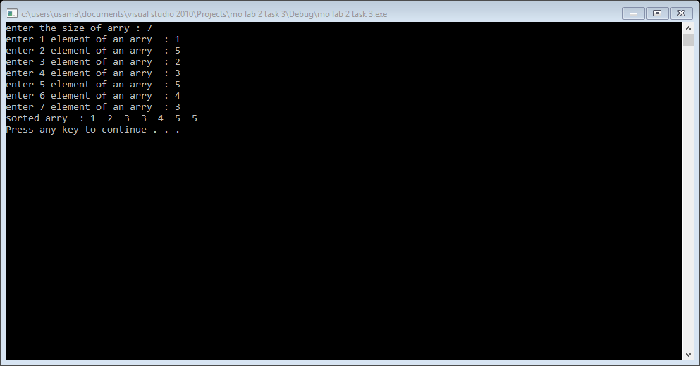

Result::reversed output::

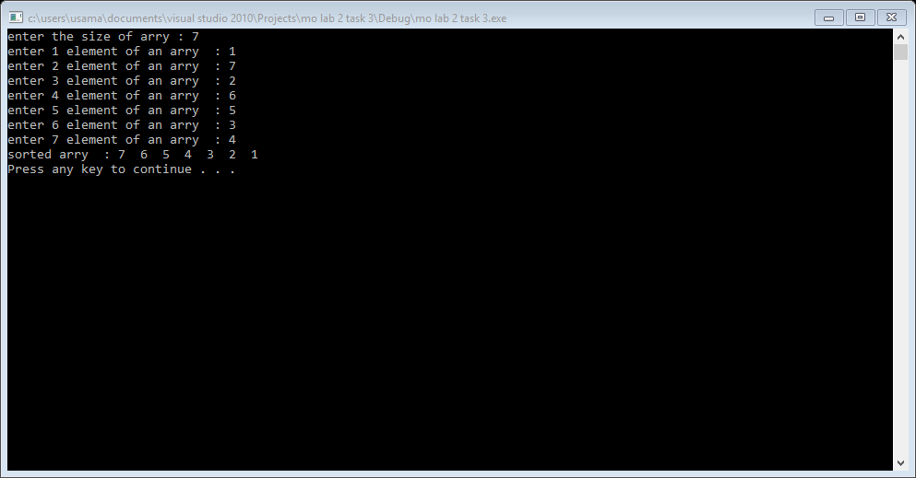

Task :: 4 ::

#include<iostream>

#include<iomanip>

using namespace std;

int main()

{

int no=0,size=0,sizeinput=0,count=0,j=0,smalli=0,temp=0;

int arry[100]={0};

int arryc[100]={0};

for(int i=0; i<100; i++)

{

cout<<"enetr marks of "<<i+1<<" student : ";

cin>>arry[i];

if(arry[i]==999)

{

size=i;

break;

}

}

for(int i=0; i<size; i++)

{

smalli=i;

for(int j=i; j<size; j++)

{

if(arry[j]<arry[smalli])

{

smalli=j;

}

}

temp=arry[smalli];

arry[smalli]=arry[i];

arry[i]=temp;

}

for(int i=0; i<size; i++)

{

for(j=0; j<size; j++)

{

if(arry[i]==arry[j])

{

count++;

}

}

arryc[i]=count;

count=0;

}

cout<<"test score"<<setw(12)<<"count"<<endl;

for(int i=0; i<size; i++)

{

cout<<arry[i]<<setw(12)<<arryc[i]<<endl;

}

system("pause");

return 0;

}

